Develop The Web Application Using Node-RED

|  |  |
| --- | --- |
| Team ID | PNT2022TMID13652 |
| Project Name | SMART WASTE MANAGEMENT SYSTEM FOR METROPOLITAN CITIES |
| Maximum Marks | 8Marks |

Aim: Develop the web application using Node- RED Steps Followed:

* 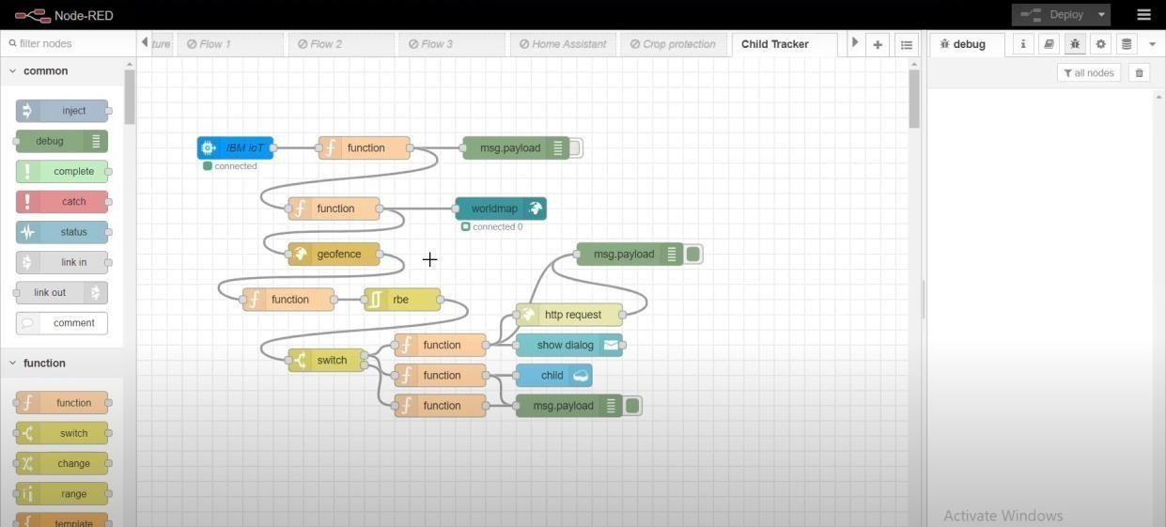Opened a Node-RED project
* Added code to get child location in python

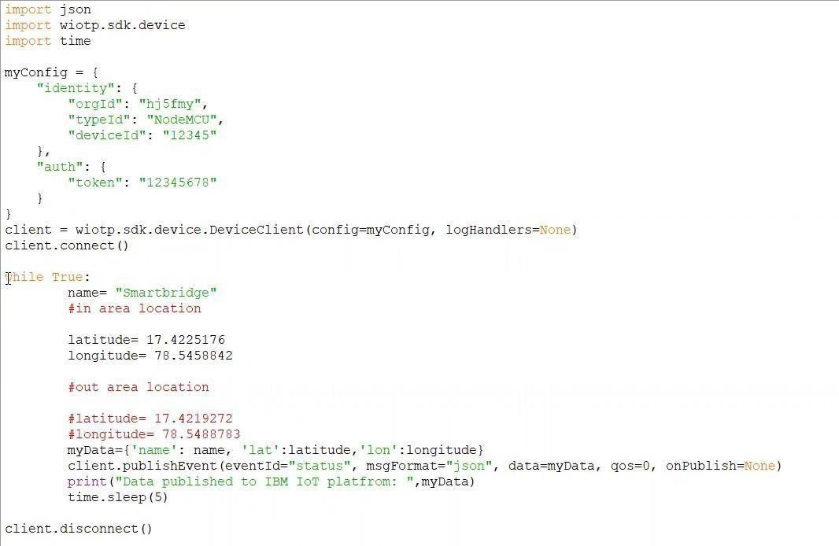

* Editing the HTTP Request URL

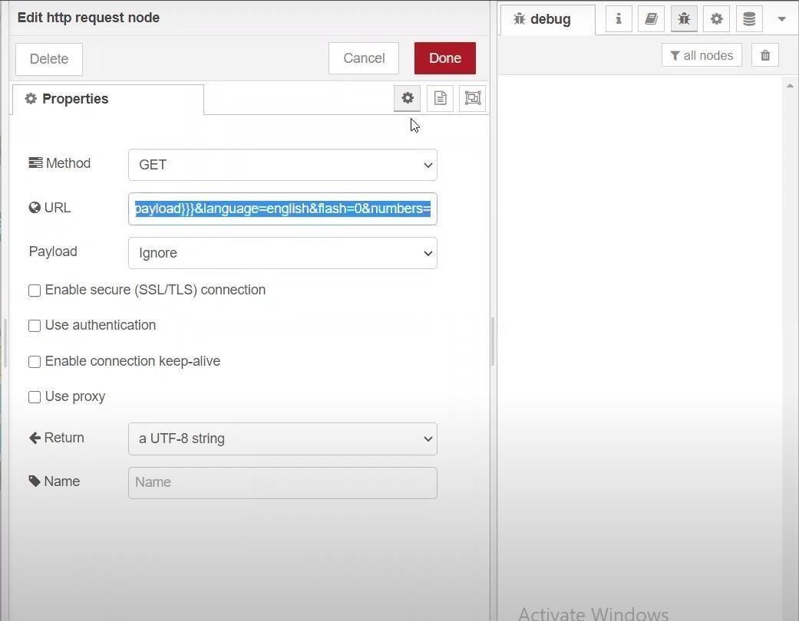

* 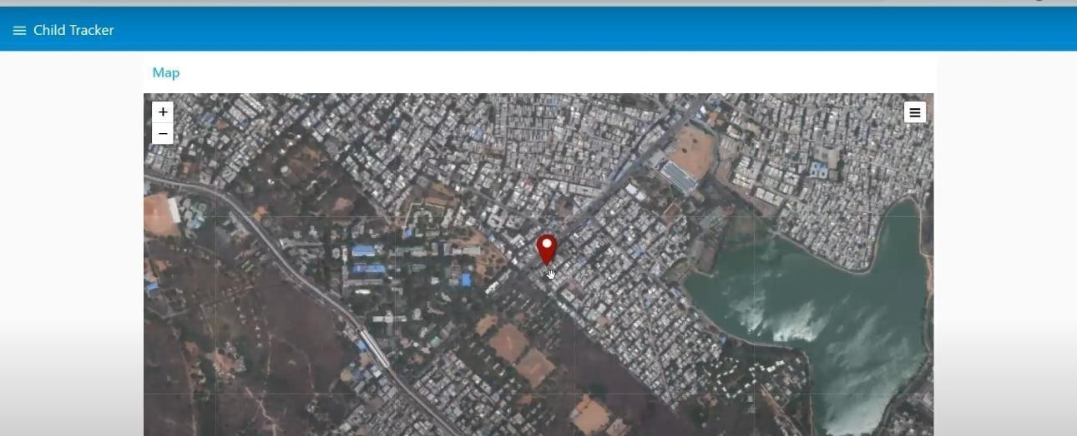Located the child
* Python script sending requests to IBM Cloud

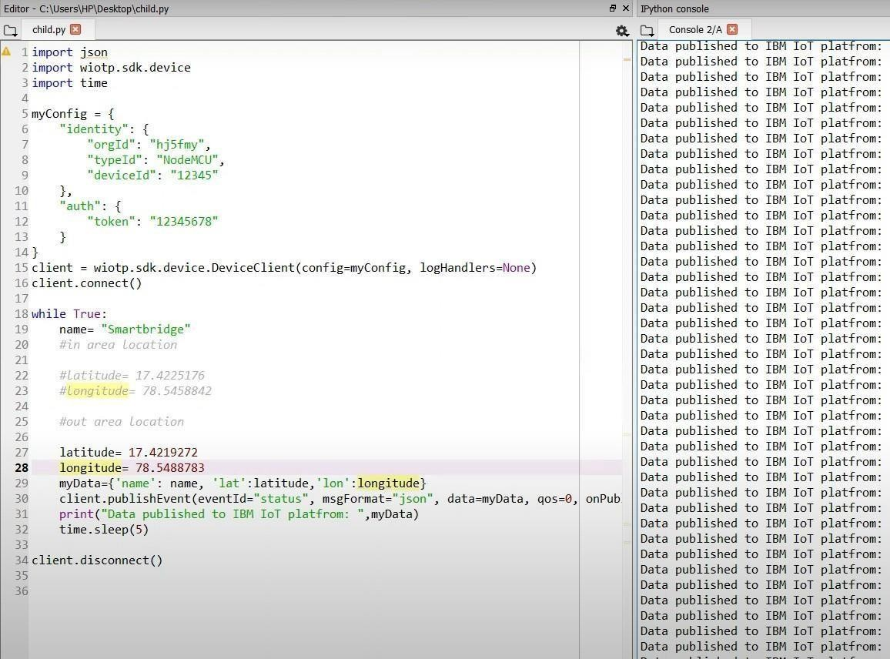

* After running the script, the web UI shows “Person is not in the particular area”

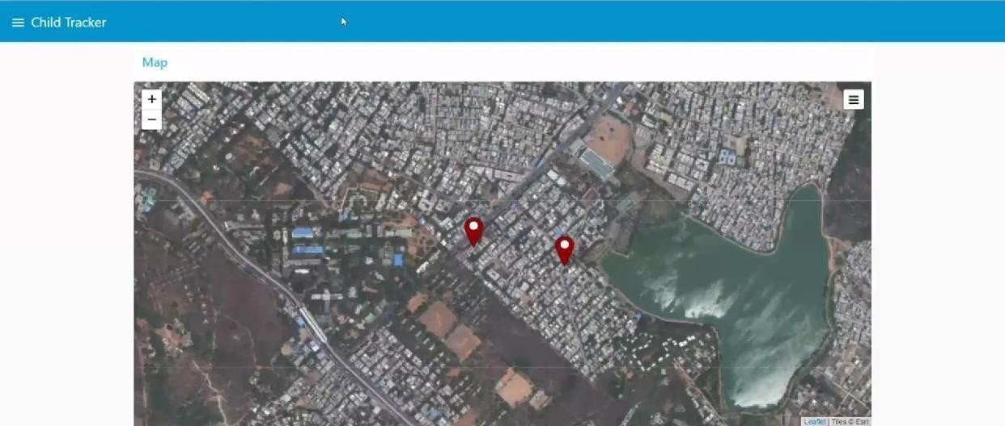

Result: Successfully developed the web application using Node-RED